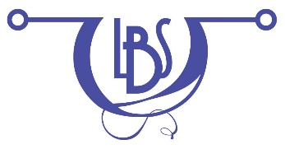

2016 Fall Bead In
Saturday November 5. 2016
9:30 am – 4:30 pm at the New Berlin Public Library

National Button Day is November 16th

Optional Activity: In celebration of National Button Day, join in the fun creating your own unique button bracelet and be ready to proudly wear your creation on the 16th. Everything is supplied to those in attendance. If you have your own stash of buttons that you would like to use, bring them with you. This project consists of attaching buttons to a chain link bracelet with jump rings, so bring two pliers (flat nose, bent nose or chain nose).

Name_________________________________________________________________________

Phone Number_____________________ Email______________________________________

If you would like to order the optional lunch (wrap, chips and cookie) from Great Wraps, please check your choice. Bring your own beverage (sorry, no alcohol allowed). Note any special lunch instructions on this form as well.

______ Village Veggie - hummus, pepper jack cheese, spinach, garlic, mushrooms, caramelized onions, green peppers, roasted
red peppers in a grilled flatbread

______ Clubhouse Wrap – turkey, ham, bacon, Swiss cheese, tomatoes, lettuce and lite ranch

______ Honey Turkey BLT Wrap – turkey, cheddar, bacon, lettuce, tomatoes, honey mustard

______ Sesame Chicken Wrap – grilled chicken, caramelized onions, sliced almonds, wonton crisps, romaine, sesame seeds,
sesame dressing

______ South Beach Tuna Wrap – tuna salad, cheddar, lettuce, tomatoes, cucumbers, sprouts, mayo

Indicate any special instructions for your lunch here______________________________________________

Member Registration Fee (required, if a member) $3.00__________

Non-member Registration Fee (required, if not a member) $5.00__________

Lunch (optional) $10.00__________

TOTAL $__________

Please make check payable to: Loose Bead Society
All reservations must be received by October 25, 2017.
Mail (or give) your registration form and check to: Becky Prusak
9617 W Forest Home Ave
Hales Corners WI 53130

Any questions can be directed to Maureen Bartz at: vpspecialevents@loosebeadsociety.org

